KWAME NKRUMAH UNIVERSITY OF SCIENCE AND TECHNOLOGY
COLLEGE OF ENGINEERING
DEPARTMENT OF AGRICULTURAL AND BIOSYSTEMS ENGINEERING

REPORT ON SIMPLE SURVEYING METHODS
BY
GROUP 6

MEMBERS

OCANSEY WELBECK KODJO 2305914
OWUSU SEKYERE ERNEST 2306514
OPOKU SAMUEL 2306214
DOTSEY EDWARD 2304414
OCRAN NICHOLAS 2306014
OPOKU DANIEL 2306114
OWUSU ANSAH GYEBI 2306414

THE LINE LEVEL

A line level consists of two identical poles. Between the poles is an inelastic string tied around each of the poles at the same level. A spirit level is suspended exactly at the midpoint of the string. The line level can be used to set out contours, grade a field and also determine elevation differences between two adjacent points.
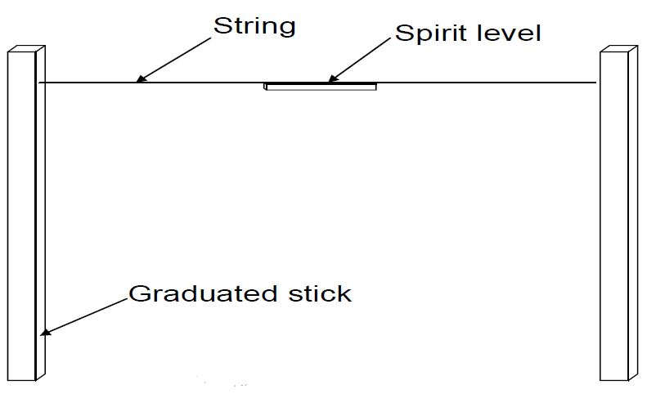

Construction of the line level
- Two identical poles were graduated at intervals of 5 cm starting from the top to about 150 cm below.
- A notch was cut on each pole at the 0 cm mark.
- The ends of an inelastic string were tied around the 0 cm mark of each pole where the notches were made to make the distance between the poles 5 m when taut.
- The midpoint of the string which was 2.5 m was marked and then a spirit level was suspended at that point.

Using the line level to determine slope of a landscape
The line level was used to determine the slope of the field behind the department building adjacent to the Ayeduase road. The procedure used is outlined below;
- An anthill was taken as the reference. From it, a distance of 6 m was ranged and pegged as (O).
- One group member (1) stood exactly upslope of the other member (2) at the reference point as demonstrated in figure 1 below.
- Ranging was done using the ranging poles and pegs to give a straight path at 5m intervals starting from member (1)’s position.
- Member (2) stood at the second peg’s position.
- Each of the two members i.e. 1 and 2 held the identical poles upright and kept the inelastic string taut.
- Member (1) adjusted the string along the pole to the mark which gives a level reading i.e. the mark where the bubble in the spirit level would lie in the middle. The adjustment gives the difference in elevation between point O and A. This was recorded.
- Next, member 1 moved to peg A and member 2 moved to peg B and then steps 5 and 6 was repeated.
- A total of five intervals was done for and tabulated as shown below.

From reference O to; | Horizontal distance from O (cm) | Vertical distance (cm) | Slope (%)
A | 500 | 51 | 10.2
B | 1000 | 55 | 11.0
C | 1500 | 50 | 10.0
D | 2000 | 54 | 10.8
E | 2500 | 54 | 10.8

The drawing of the path ranged is attached for clarification.

THE A-FRAME
An A-frame consists of wooden frames joined together and manipulated to form an A shape with a plummet or spirit level utilized to determine points of equal height, measure slope of known percentage and also mark out contours on a field.
Construction of the A-frame
Materials needed
- 2 identical straight poles;
- A crossbar;
- A plummet;
- Marker or knife;
- An inelastic string/ plumb line.
- nails
Procedure

- The two identical poles were nailed together to form a V shape.
- The crossbar was nailed approximately at the midsection of each of the two identical poles at the ends to give support to the frame. This gives an A shape and the distance between the legs was 2 meters.
- The plumb line was tied around the plummet and suspended at the top of the A frame where the two identical poles were joined.

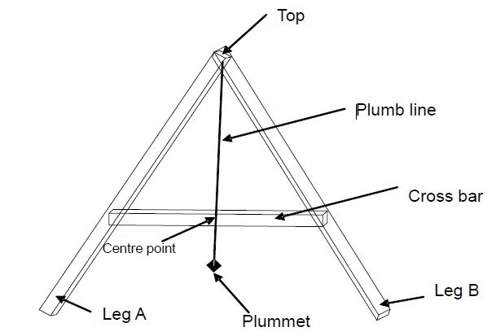
Figure 3: The A-frame.

Calibrating the A-frame
Before the A-frame was used, it was calibrated in order to give accurate readings on the field.
The following were the steps followed in calibrating the A-frame;
- The A-frame was placed upright on its legs on a nearly flat surface with slope approaching zero
- A mark was made on the surface where the two legs stood with the marker.
- The plummet was allowed to settle and the point at which it crossed the crossbar was marked.
- The A-frame was turned $180°$ laterally such the legs’ positions were interchanged.
- Again, the plummet was allowed to settle and a second mark was made on the crossbar.
- For ideal situations, the marks should be at the same point on the crossbar but in our case, we had two marks at different positions. Half the distance between the two marks was taken and marked as our reference.

Setting out contours using the A-frame
After the calibration, the A-frame was employed to mark two contour lines on the field behind the department building. The procedure used is outlined below;
- A soak-away was used as the reference landmark. A distance of 14 m was taken from the reference by ranging and pegging to the starting point 0.
- The A-frame was operated by one group member. One leg (A) of the A-frame was placed at the starting point 0 and the other leg(B) was turned around by trial and error to locate a position where the plumb line would cross the crossbar at the reference mark when the plummet settled.
- That position found was pegged and the procedure was repeated with leg (B) being the fulcrum at the newly found position.
- In all five desired positions were found and joined with an imaginary line to form contour (A).
- Another contour (B) was set at a distance of 2 form contour A.

Using the A-frame to grade a field at a known percentage
The A-frame can also be used to grade a field at a known percentage say 4%. For this to be done, the A-frame requires calibration.
Calibrating the A-frame to grade a field at percentage of 5%
- A grade percentage of 5 was used which required a block height of 10 cm since$slope\left(\%\right)=\frac{vertical distance}{horizontal distance}×100$ the distance between the legs of the A-frame was 2 m.
- The block was placed against wall and a wooden plank with a flat surface was place on the block with one end touching the ground.
- The A-frame was placed upright on the wooden plank and the plummet was allowed to settle.
- The position at which the plumb line crossed the crossbar was marked.
- This meant any point in time when the plumb line lied on that mark, a slope of 5 % was encountered.
On the field a distance of 6 meters was taken from a tree behind the department. That position was pegged and used as our reference point. The grading was done in the same manner as the contouring and the pattern was drawn. All drawings are attached to this report.

THE N-FRAME

